Google Survey Form

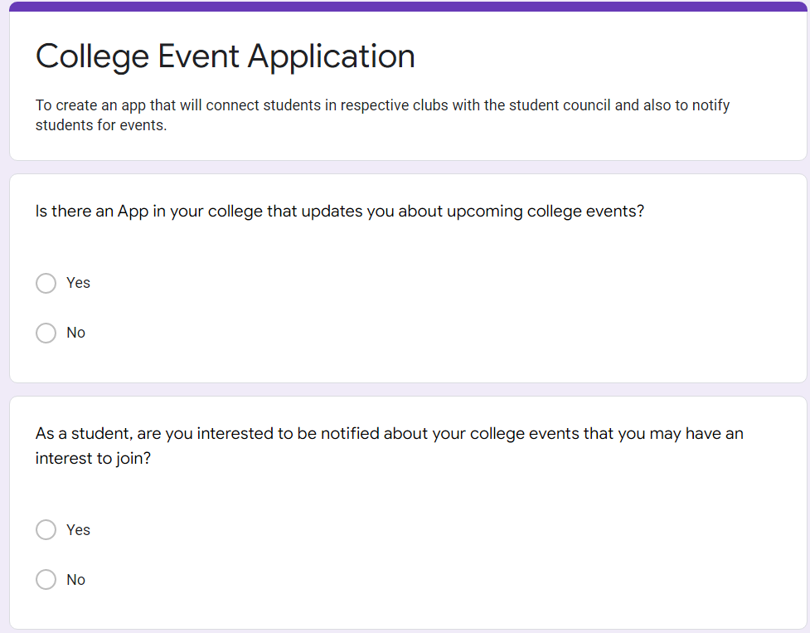

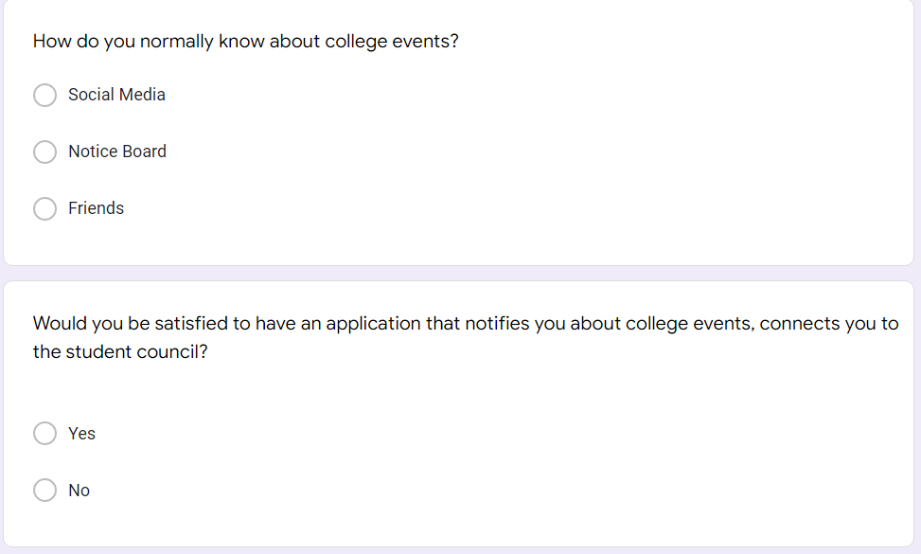

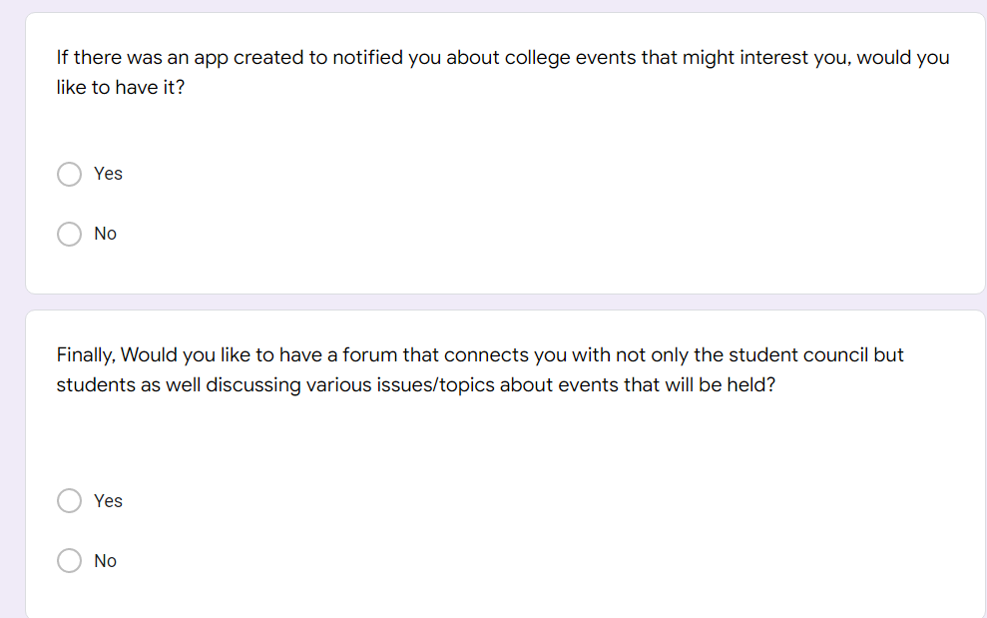

Responses

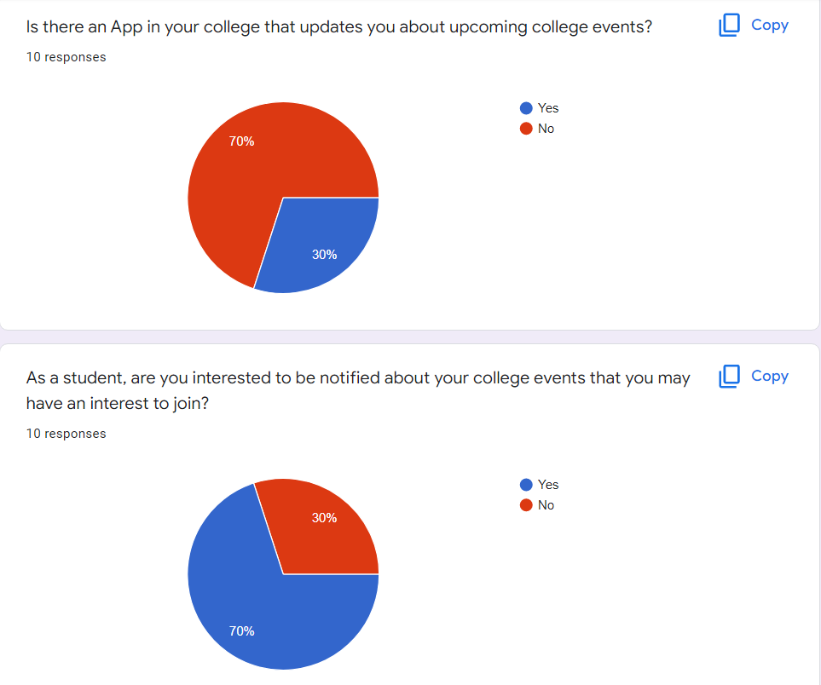

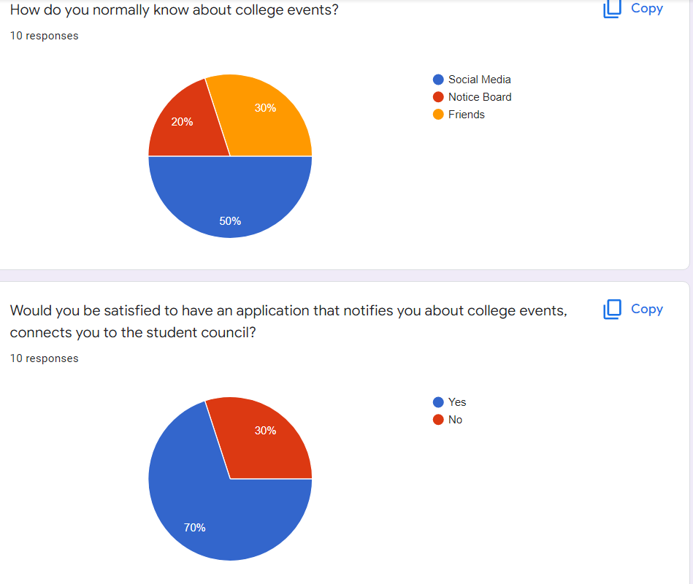

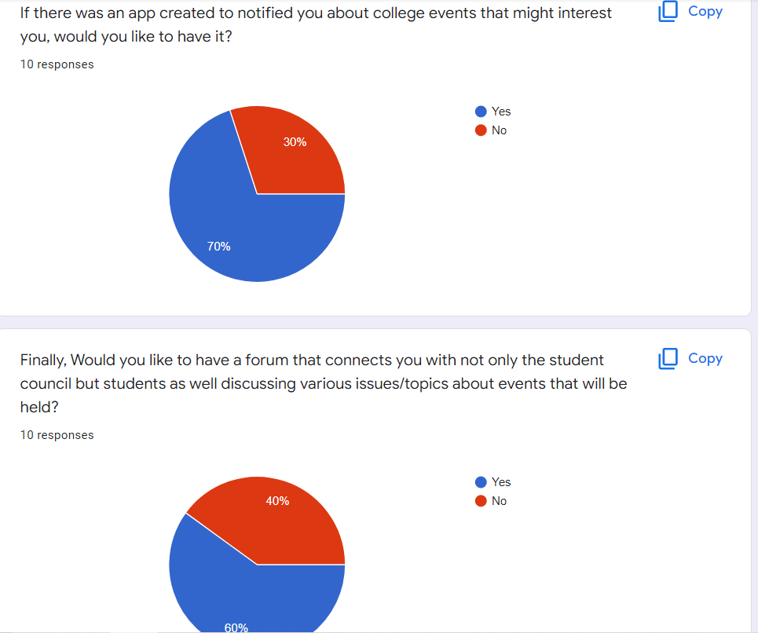

User Story Map

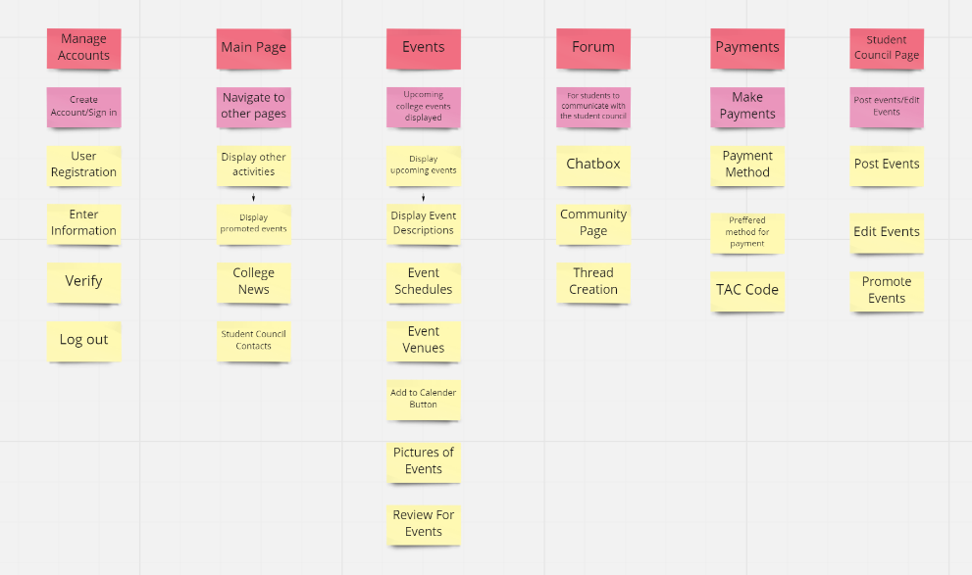

Vision

What is the problem?

From the survey I have conducted. Based on the responses, most users prefer to have an application in their college to notify them about upcoming events to join with their respectives clubs. They mostly get to know about these events through the notice board, social media and their friends. The problem here is not many students will get information about upcoming events, therefore resulting in a non-successful event.

I have decided to make an application where it would solve this problem. This app will allow students to communicate with the student council for further details about the events. It will also have a forum where students can share their opinions on the events and also discuss various topics.

The users will be students, and also lecturers. This is the target because I am focusing on the benefits of the college itself and how it can help to not only promote its events but also boost the interest of students and lecturers to add in more effort for promoting their events.